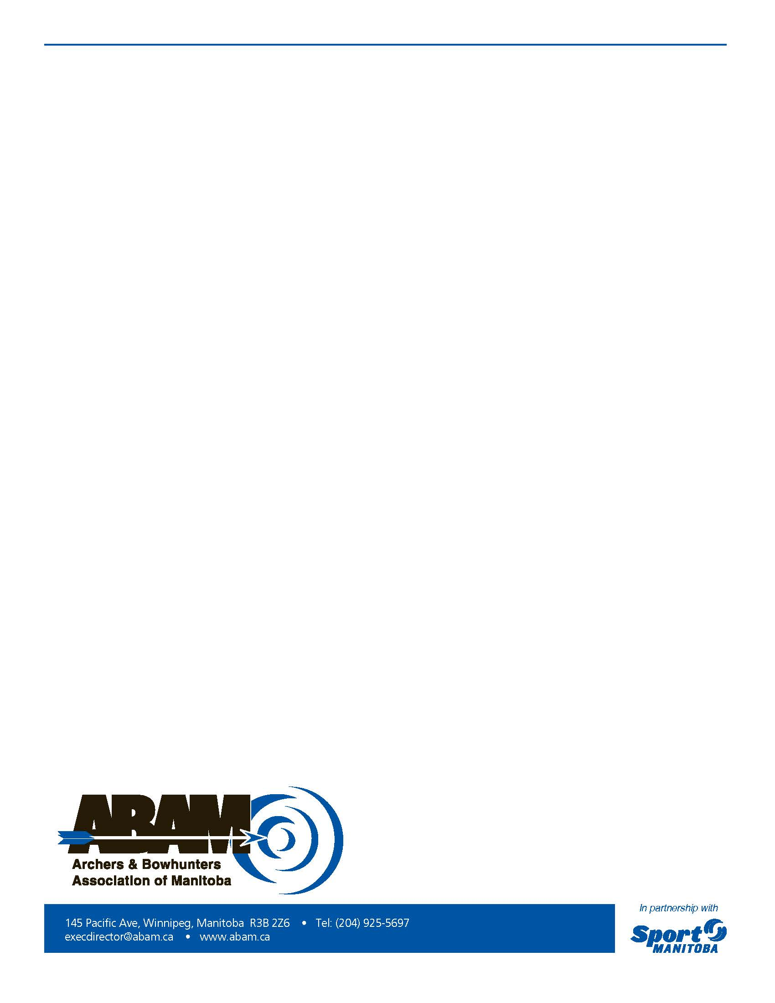

**BOWHUNTING PIN AWARDS**

The Bowhunting Committee of the ABAM is again offering the Bowhunting

“PIN AWARDS” for members who harvest game under fair chase in the 2015 hunting season.

These pins are given for any legally taken animal under a provincially issued Manitoba hunting license.

We have pins for turkey, bear, deer, moose, elk and caribou.

If you are an ABAM member in 2015 and harvest one of the species above simply complete the form below and mail it to the ABAM (regular mail or electronic) by Jan 15, 2016. You can apply for an award for each species that you harvest.

We will mail the pin to you.

Good luck!

Member Name ___________________________________ ABAM number_______

Address___________________________________ City _______________________

Postal Code__________ ______________ Phone number _____________________

Email______________________________ Type of animal ______________________

Manitoba Hunting License #___________________